**Personal, Social, Health, Economic**  **(PSHE) Education Policy**

**Including Relationships and Health Education statutory from September 2021, and our position on Sex Education**

|  |  |
| --- | --- |
| Created: | September 2024 |
| Reviewed: |  |
| To be reviewed: | September 2025 |

# CONTENTS

Introduction and Context .................................................................................................................................. 3

PSHE ................................................................................................................................................................... 3

Statutory Requirements ..................................................................................................................................... 3

Definitions ............................................................................................................................................................ 4

Curriculum Delivery ............................................................................................................................................ 4

Primary Curriculum Content ............................................................................................................................. 5

Secondary Curriculum Content ........................................................................................................................ 6

Special Educational Needs and/or Disabilities ............................................................................................... 6

Equality ................................................................................................................................................................ 7

Assessment ......................................................................................................................................................... 7

Roles and Responsibilities ................................................................................................................................ 7

Parents Right to Withdraw ..................................................................................................................................8

Policy Development ........................................................................................................................................... 9

Policy Monitoring and review ............................................................................................................................ 9

Appendix 1........................................................................................................................................................... 11

Appendix 2.......................................................................................................................................................... 13

**INTRODUCTION AND CONTEXT**

Skylarks School is an independent school providing specialist education for children and young people aged 8 – 16 with a range of Complex Needs. All of our children and young people have significant barriers to learning due to their complex learning difficulties and disabilities in the area of autistic spectrum conditions, moderate to severe learning difficulties, associated medical and health issues and moderate mental health conditions. All of our young people are extremely vulnerable and many have experienced disruption to formal education. For some pupils, this has resulted in long periods of absence which has impacted on their self-esteem and self-confidence.

At Skylarks School we believe all young people deserve the right to an education that will support them to become happy and confident individuals with skills, qualifications and achievements that will support them in their future. The overriding aim of our curriculum and wider work is to achieve the best possible outcomes for our young people in terms of individual learning, independence, personal growth and development and personal safety. We aim to provide pupils with an understanding about the wider world to enable them to make informed, appropriate choices and decisions where possible. Our PSHE curriculum is flexible, adaptable and robust enough to meet the ever changing demands of the modern world, and best prepare our young people for a life within it.

# PSHE

At Skylarks School, we teach Personal, Social, Health, Economic education as a whole-school approach to underpin our students’ development as people because we believe this best supports their learning capacity. We follow the PSHE Education Planning Framework for Pupils with SEND written by the PSHE Association (see Appendix 1 & Appendix 2) to ensure our curriculum integrates, but is not limited to, the new statutory content. Our Personal, Social, Health, Economic education also includes Relationships and Sex Education (RSE), Life Skills, enterprise, financial capacity and Careers education (following the Gatsby Benchmarks as part of the DfE Careers Strategy).

Our broad and balanced PSHE curriculum helps our young people to become informed, thoughtful and responsible citizens who are aware of British Values and their duties and rights. It encourages pupils to make a positive contribution to the life of their school, neighbourhood, communities and the wider world. It encourages respect for different nation, religious and ethnic identities. It also helps students to develop an understanding of career managements and employability skills as well as developing an understanding about the world of work.

# STATUTORY REQUIREMENTS

“The Relationships Education, Relationships and Sex Education and Health Education (England)

Regulations 2019, made under sections 34 and 35 of the Children and Social Work Act 2017, make

Relationships Education compulsory for all pupils receiving primary education…They also make

Health Education compulsory in all schools except independent schools. Personal, Social, Health and

Economic Education (PSHE) continues to be compulsory in independent schools.”

DfE Guidance p.8

In Key Stage 1 and 2 we teach Relationships education with Sex education being taught discretely in line with cognition and receptive understanding (This is determined in consultation with the Clinical Team, SMT and parents), with all Key Stages being taught Health Education, thus following the statutory guidance as set out by the Department of Education and the Independent School Standards. (**Due to the nature of needs and the pupils cognitive ability-We follow K1/2 curriculum to support their learning and emotional development. Should it be possible for Students to access the KS3/4 curriculum, class teacher will plan for this in line with student ability)**

In addition, at Skylarks School:

* Teaching reflects the law and teaches about applicable laws so that pupils are clear on rights and responsibilities
* Teaching is sensitive, inclusive, and age-appropriate
* Teaching is inclusive to meet the needs of all pupils so that they are able to understand the importance of quality and respect
* We work closely with parents and are respectful of pupils’ and parents’ backgrounds and beliefs
* We communicate the right to request withdrawal from some or all of the sex education
* We will take into account the age and religious background of all pupils
* We make sure that RSHE is accessible to all pupils, including those with SEND
* We teach about LGBT+ content at integrated and timely point
* The staff team and wider community model positive relationships

Skylarks School complies with the Equality Act 2010:

* We will not treat pupils with protected characteristics (age, sex, race, disability, religion or belief, gender reassignment, pregnancy or maternity, marriage or civil partnership, or sexual orientation less favourably.
* We will make reasonable adjustments and take positive action to alleviate disadvantage, being mindful of the SEND Code of Practice.
* We will regularly review our Accessibility Plan to ensure we are taking positive action towards inclusivity.

# DEFINITIONS

**Relationships and Sex Education** (RSE) is about the emotional, social and cultural development of pupils, and involves learning about relationships, sexual health, sexuality, healthy lifestyles, diversity and personal identity. RSE involves a combination of sharing information, and exploring issues and values. RSE is not about the promotion of sexual activity.

**Health Education** is focused on teaching pupils how to make good decisions about their own physical health and mental wellbeing. It involves learning about what is normal and what is an issue and teaches pupils how and who to seek support when needed.

# CURRICULUM DELIVERY

“Schools are free to determine how to deliver the content set out in the DfE guidance 2019 in the context of a broad and balanced curriculum. Effective teaching in these subjects will ensure that core knowledge is broken down into units of manageable size and communicated clearly to pupils, in a carefully sequenced way, within a planned programme of lessons.”

DfE Guidance p.8

At Skylarks School, we include the statutory Relationships and Health Education and Sex Education within our whole-school Personal, Social, Health, Economic (PSHE) education curriculum. Biological aspects of Relationships and Sex Education are also taught within the science curriculum to some classes (dependent on the curriculum pathway).

We allocate one hour each week to teach the PSHE Framework, as well as additional timetabled PSHE lessons to focus on life skills, Careers and Personal Development. The allocated time varies dependent on the learners’ needs within that class and the curriculum pathway they are following.

At Skylarks School we use a holistic, person-centered approach to the development of our young people to ensure they achieve the best possible outcomes. Although we follow a framework that is organised into key stages, our PSHE curriculum is flexible and key stages are followed depending on the individual needs and main areas of development within that class, as opposed to their age group.

Teachers take into account the needs and feelings of pupils’ and deliver the content of the PSHE curriculum in a developmental and age-appropriate way suited to individual needs. Each class also accesses assemblies and has praise and reward systems in place that are personalised for their pupils.

**PRIMARY CURRICULUM CONTENT**

# Relationships Education

The Key Stage 1 and 2 Relationships education focuses on teaching the fundamental building blocks and characteristics of positive relationships including:

* Families and close positive relationships
* Friendships
* Managing hurtful behaviour and bullying
* Safe relationships
* Respecting self and others

# Sex Education

The DfE Guidance 2021 (p.23) recommends that all primary schools ‘have a sex education programme tailored to the age and the physical and emotional maturity of the pupils’.

However, ‘Sex Education is not compulsory in primary schools’. (p.23)

Schools are to determine the content of sex education at primary school. Sex education ‘should ensure that both boys and girls are prepared for the changes that adolescence brings and – drawing on knowledge of the human life cycle set out in the national curriculum for science - how a baby is conceived and born’.

We define sex education as understanding human reproduction. We believe that all children at our school should have access to a sex education programme to enable them to:

* Be safe
* Be provided with the correct scientific terminology and information and taught how to use it in the right context
* Make responsible, informed and healthy choices about their lives now and in the future
* Be respectful of themselves and others to enable them to move confidently through childhood, adolescence into adulthood
* Have the understanding to develop and maintain positive and healthy relationships

# Health Education

The Key Stage 1 and 2 Health Education focuses on the following key areas:

* Mental wellbeing
* Internet safety and harms
* Physical health and fitness
* Healthy eating
* Drugs, alcohol and tobacco
* Health and prevention
* Basic first aid
* Changing adolescent body

Teaching children about puberty is now a statutory requirement which sits with the Health Education part of the DfE guidance within the ‘Changing adolescent body’ strand. **Sex Education**

# CURRICULUM CONTENT

The Key Stage 2 Sex Education focuses on giving young people the information they need to help them develop healthy, nurturing relationships of all kinds including:

* Families
* Respectful relationships, including friendships
* Online and media
* Being safe
* Intimate and sexual relationships, including sexual health

These areas of learning are taught within the context of family life taking care to ensure that there is no stigmatisation of children based on their home circumstances (families can include single parent families, LGBT+ parents, families headed by grandparents, adoptive parents, foster parents/carers amongst other structures) along with reflecting sensitively that some children may have a different structure of support around them (for example: looked after children or young carers).

# Health Education

The Key Stage 3 and 4 Health Education curriculum continues to develop knowledge on topics specified for primary as required and in addition covers the following content by the end of secondary:

* Mental wellbeing
* Internet safety and harms
* Physical health and fitness
* Healthy eating
* Drugs, alcohol and tobacco
* Health and prevention
* Basic first aid
* Changing adolescent body

**See Appendix 1 and Appendix 2 for a more details on the curriculum content.**

# SPECIAL EDUCATIONAL NEEDS AND/OR DISABILTIES

All pupils at Skylarks School have additional learning needs and all have an Education Health Care Plan (EHCP). Skylarks School is committed to providing the environment and opportunities to enable all children and young people with special educational needs to be included, fully, in all aspects of school life. We have adapted our curriculum to ensure each young person has access to a broad and balanced curriculum that is meaningful, appropriate and individually challenging. Classroom resources are differentiated as appropriate to address the learning needs of each pupil in order for them to have full access to the contents of the PSHE and RSE curriculum. All teaching and learning opportunities are underpinned with specific objectives, based on individual needs. EHCP outcomes are integrated into the school day and embedded throughout our curriculum. In addition, our health and therapy team work closely together and in collaboration with school, parents/carers and other professionals to provide a holistic approach.

# EQUALITY

The DfE Guidance 2021 (p. 15) states, “Schools should ensure that the needs of all pupils are appropriately met, and that all pupils understand the importance of equality and respect.

Schools must ensure they comply with the relevant provisions of the Equality Act 2010 under which sexual orientation and gender reassignment are amongst the protected characteristics…”

LGBT content is integrated fully into our curriculum. It is not specifically taught as stand-alone lessons within units. All young people will be taught LGBT+ content in an age appropriate manner at a timely point in the curriculum.

At Skylarks School we promote respect for all and value every individual child. However, we also respect the rights of our children, families and our staff to hold beliefs, religious or otherwise.

Should any content within our curriculum cause parents or carers any concern then we would invite them in to discuss these concerns with the school.

For information on what is taught, please refer to Appendix 1 and Appendix 2.

# ASSESSMENT

Assessment is integral to teaching and learning in PSHE and is carried out in accordance with the whole-school policy. We use the PSHE Education Assessment Framework for Pupils with SEND to help track our young people’s progress in PSHE and identify areas of development. Our assessment is ongoing and is continually captured throughout the school day when our pupils are seen applying their skills and knowledge in real-life situations or to different subjects using Evidence for Learning.

The style of assessment used is non-threatening and promotes the young people’s self-esteem. There are clearly defined links between objectives and assessment. The criteria by which the work is to be judged are shared and accessible by the young people, where appropriate. Assessment is continuous and the outcomes of the process are used to inform subsequent teaching. Young people receive regular feedback from their teachers concerning their progress and achievement and this is communicated to parents, carers and associated professionals in termly subject reports and in the statutory annual review documentation.

# ROLES AND RESPONSIBILITIES

**The Headteacher**

The Headteacher is responsible for ensuring that RSE is taught consistently across the school, and for managing requests to withdraw pupils from the non-statutory components of RSE.

# Staff

Staff are responsible for:

* Delivering RSE in a sensitive way
* Modelling positive attitudes to RSE
* Monitoring progress
* Responding to the needs of individual pupils
* Responding appropriately to pupils whose parents wish them to be withdrawn from the non- statutory components of RSE
* Communicating with parents when Sex Education is being delivered

Teachers are timetabled to deliver PSHE lessons to classes for the full academic year to ensure consistency, but PSHE is not always taught to classes by their form tutor.

Staff do not have the right to opt out of teaching RSE. Staff who have concerns about teaching RSE are encouraged to discuss this with the Headteacher.

# PSHE Subject Lead

The PSHE Subject Lead is responsible for ensuring pupils are receiving high quality PSHE lessons that are accessible and tailored to individual needs. They will ensure the framework informs planning, teaching and assessment. They will share knowledge, good practice and keep staff up to date with the current statutory guidance.

# Health and Therapy Team

Our Clinical team at Skylarks School comprises of Clinical Child

Psychologist, Child and Adolescent Psychiatrist, Speech and Language Therapists and Occupational Therapists. Our team provide information to support a holistic approach to the teaching and learning of PSHE. They provide advice, guidance and resources to support staff in ensuring all young people can access our PSHE curriculum. They may also provide 1:1 support to deliver specific interventions based on individual needs.

# Pupils

Pupils are expected to engage fully in PSHE and, when discussing issues related to PSHE, treat others with respect and sensitivity.

# PARENTS RIGHT TO WITHDRAW

“Parents have the right to request that their child be withdrawn from some or all of sex education delivered as part of statutory Relationships and Sex Education”

DfEGuidance p.17

All staff at Skylarks School strongly believe that all children should have access to our sex education programme as outlined above. If a parent/carer wishes to withdraw their child from Sex Education lessons, then they must inform the school in writing a week prior to the lesson taking place in order that alternative arrangements can be made for the child’s education.

# Key Stage 2

Parents do not have the right to withdraw their children from relationships education.

Parents have the right to withdraw their children from the non-statutory components of sex education within RSE.

Requests for withdrawal should be put in writing and addressed to the Headteacher. Alternative work will be given to pupils who are withdrawn from sex education.

There are separate rules on withdrawing a child from Sex Education. Sex education is separate from the Relationships and Health curriculum and parents can withdraw children from some or all of the lessons on Sex Education. The head teacher must grant a parent’s request to withdraw a child beforehand, and it’s useful to have good conversations with parents so that they understand fully what their child will be taught.

Before making a request, parents should:

Ask the school about what will be taught in Sex Education, and when.

Remember that the science curriculum in all schools includes content on human development, which includes human reproduction.

Remember there is no right for a parent to withdraw their child from the science curriculum**.**

# Key Stage 2 (Sex Education)

Parents have the right to withdraw their children from the non-statutory components of sex education within RSE up to and until 3 terms before the child turns 16.

Requests for withdrawal should be put in writing and addressed to the Headteacher.

A copy of withdrawal requests will be placed in the pupil’s educational record. The Headteacher will discuss the request with parents and take appropriate action.

Alternative work will be given to pupils who are withdrawn from sex education.

# POLICY DEVELOPMENT

This policy has been developed in consultation with staff, pupils and parents. The consultation and policy development process involved the following steps:

* Review – a member of staff or working group pulled together all relevant information including relevant national and local guidance
* Staff consultation – all school staff were given the opportunity to look at the policy and make recommendations
* Parent/stakeholder consultation – we wrote to parents to outline our plans for what is going to be taught and how. Parents and stakeholder views are considered. This policy will be shared with parents. Parents will be invited to share their views.
* Pupil consultation – we investigated what exactly pupils want from their PSHE and RSE lessons
* Ratification – once amendments were made, the policy was shared with governors and ratified

# POLICY MONITORING AND REVIEW

The senior leadership team monitor this policy on an annual basis.

**APPENDIX 1:** HOW THE PSHE EDUCATION PLANNING FRAMEWORK FOR PUPILS WITH SEND RELATES TO THE PSHE ASSOCIATION PROGRAMME OF STUDY

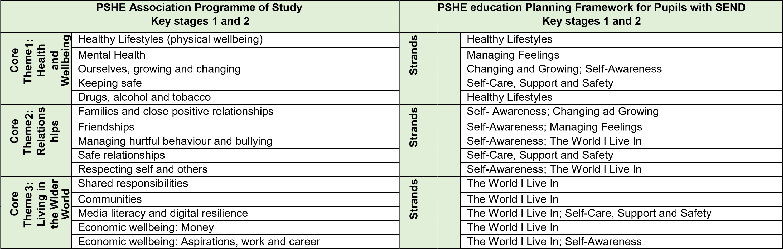

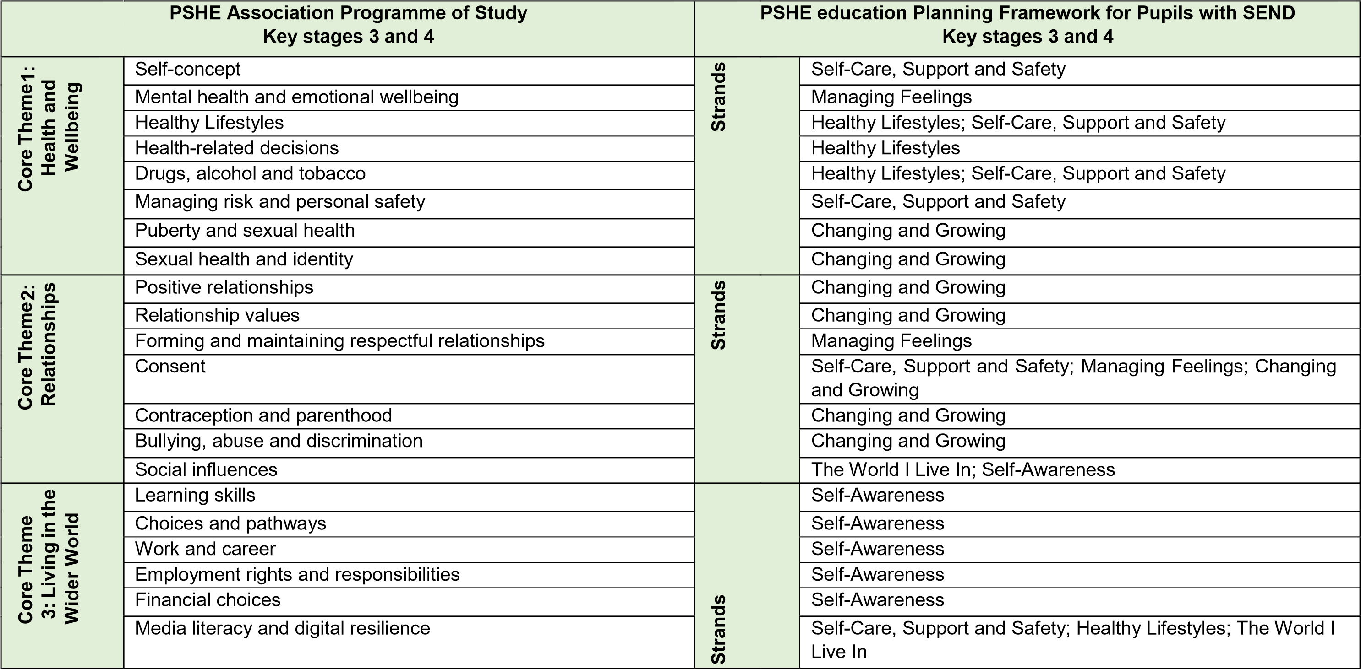

**APPENDIX 2:** HOW THE PLANNING FRAMEWORK FOR PUPILS WITH SEND MAPS AGAINST THE

DFE STATUTORY GUIDANCE FOR RELATIONSHIPS EDUCATION, RSE AND HEALTH EDUCATION

# RELATIONSHIPS EDUCATION PRIMARY

**Topic**  **Content grids from the DfE statutory guidance: Relationships Education PSHE education Planning Framework for Pupils with SEND**

## (Primary) KEY STAGES 1 and 2

**By the end of primary school pupils should know:**  **Section and row references:**

* that families are important for children growing up because they can give love, Self-Awareness: SA4 security and stability
* the characteristics of healthy family life, commitment to each other, including in Self-Awareness: SA4, SA5 Changing times of difficulty, protection and care for children and other family members, and Growing: CG4 the importance of spending time together and sharing each other’s lives.
* 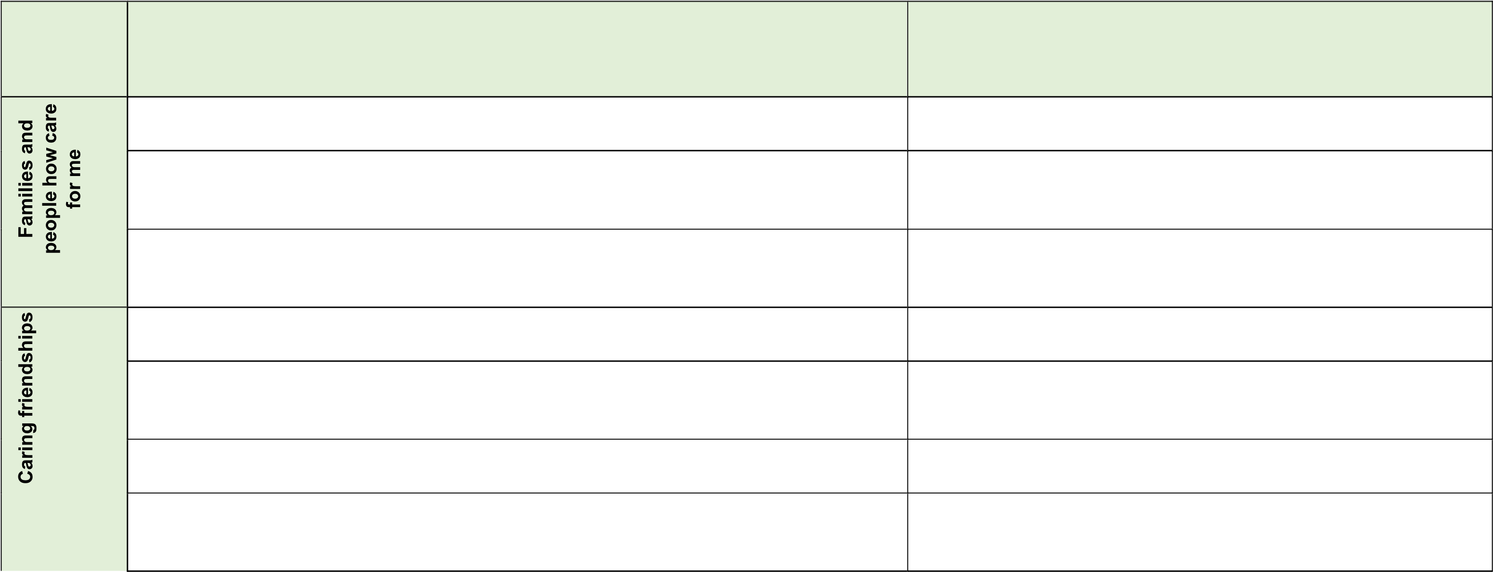that others’ families, either in school or in the wider world, sometimes look Changing and Growing: CG4 Self-Awareness: different from their family, but that they should respect those differences and SA5 know that other children’s families are also characterised by love and care.
* how important friendships are in making us feel happy and secure, and how people Self-Awareness: SA4 choose and make friends.
* the characteristics of friendships, including mutual respect, truthfulness, Self-Awareness: SA5 trustworthiness, loyalty, kindness, generosity, trust, sharing interests and experiences and support with problems and difficulties.
* that healthy friendships are positive and welcoming towards others, and do not Self-Awareness: SA5

make others feel lonely or excluded.

* that most friendships have ups and downs, and that these can often be worked Self-Awareness: SA4, SA5 through so that the friendship is repaired or even strengthened, and that resorting to violence is never right.

|  |  |  |  |
| --- | --- | --- | --- |
|  | • | how to recognise who to trust and who not to trust, how to judge when a friendship is making them feel unhappy or uncomfortable, managing conflict, how to manage these situations and how to seek help or advice from others, if needed. | Self-Awareness: SA4, SA5  Self-Care, Support and Safety: SSS3 |

* the importance of respecting others, even when they are very different from Self-Awareness: SA3 them (for example, physically, in character, personality or backgrounds), or make different choices or have different preferences or beliefs.
* practical steps they can take in a range of different contexts to improve or Self-Awareness: SA3

support respectful relationships. Managing Feelings: MF2

* the conventions of courtesy and manners. Self-Awareness: SA3
* the importance of self-respect and how this links to their own happiness Self-Awareness: SA4, SA5
* that in school and in wider society they can expect to be treated with respect Self-Awareness: SA2

by others, and that in turn they should show due respect to others, including

those in positions of authority.

* about different types of bullying (including cyberbullying), the impact of Self-Awareness: SA2 bullying, responsibilities of bystanders (primarily reporting bullying to an adult) The World I Live In: WILI 1 and how to get help.
* what a stereotype is, and how stereotypes can be unfair, negative or The World I Live In: WILI 1 destructive.
* the importance of permission-seeking and giving in relationships with friends, Changing and Growing: CG1 peers and adults.
* that people sometimes behave differently online, including by pretending to be Self-Care, Support and Safety: SSS4 someone they are not.
* 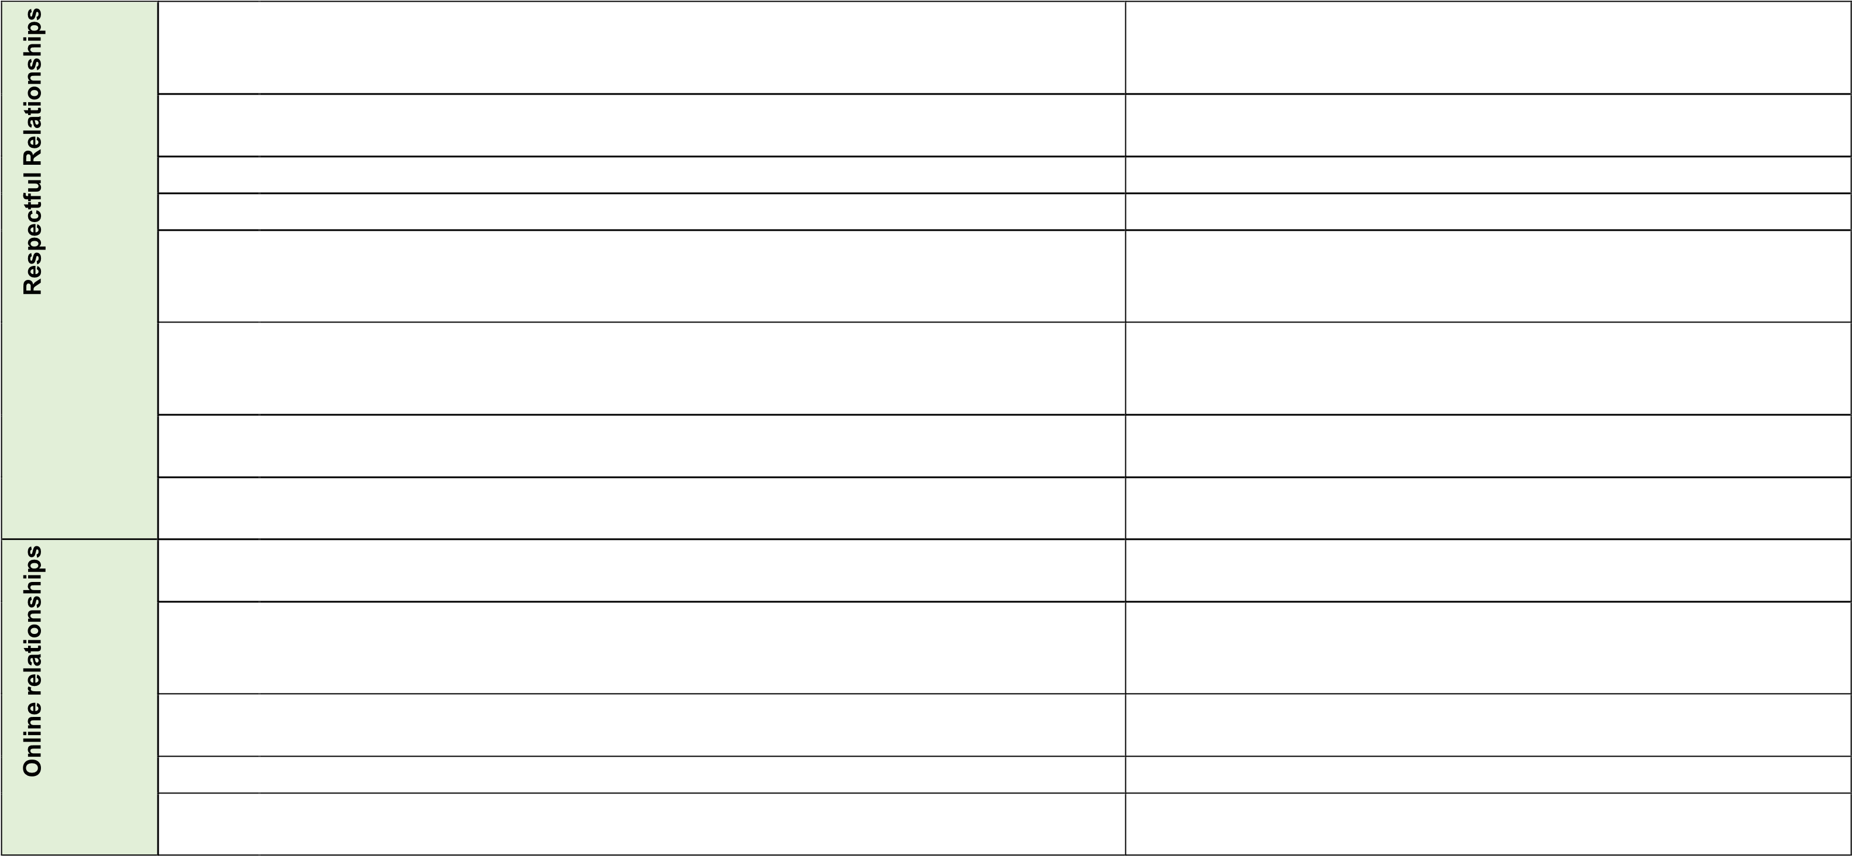that the same principles apply to online relationships as to face-to-face Self-Care, Support and Safety: SSS4 relationships, including the importance of respect for others online including when we are anonymous.
* how to critically consider their online friendships and sources of information Self-Care, Support and Safety: SSS4 Self-Awareness:

including awareness of the risks associated with people they have never met. SA2

* how information and data is shared and used online. Self-Care, Support and Safety: SSS4
* the rules and principles for keeping safe online, how to recognise risks, harmful content and contact, and how to report them.

Self-Care, Support and Safety: SSS2, SSS3, SSS4

* what sorts of boundaries are appropriate in friendships with peers and others (including in a digital context).
* about the concept of privacy and the implications of it for both children and adults; including that it is not always right to keep secrets if they relate to being

safe.

Self-Care, Support and Safety: SSS3

|  |  |  |  |  |  |  |  |  |  |  |  |  |  |
| --- | --- | --- | --- | --- | --- | --- | --- | --- | --- | --- | --- | --- | --- |
| * that each person’s body belongs to them, and the differences between Self-Care, Support and Safety: SSS5 Changing appropriate and inappropriate or unsafe physical, and other, contact. and Growing: CG3 * how to respond safely and appropriately to adults they may encounter (in all Self-Care, Support and Safety: SSS2, SSS3 contexts, including online) whom they do not know.      |  |  |  |  | | --- | --- | --- | --- | |  | • | how to recognise and report feelings of being unsafe or feeling bad about any adult. | Self-Care, Support and Safety: SSS3, SSS4 | | • | how to ask for advice or help for themselves or others, and to keep trying until they are heard. | Self-Care, Support and Safety: SSS2, SSS4 | | • | how to report concerns or abuse, and the vocabulary and confidence needed to do so. | Self-Care, Support and Safety: SSS4, SSS5  Changing and Growing: CG3 Self-  Awareness: SA2 | | • | where to get advice (e.g. family, school and/or other sources). | Self-Awareness: SA2, SA5  Self-Care, Support and Safety: SSS3, SSS4 Changing and Growing: CG3 | |

Self-Care, Support and Safety: SSS3



# HEALTH EDUCATION PRIMARY

**Topic**  **Content grids from the DfE statutory guidance: Health Education (Primary)**

**By the end of primary school pupils should know:**

## PSHE education Planning Framework for Pupils with SEND KEY STAGES 1 and 2

**Section and row references:**

* that mental wellbeing is a normal part of daily life, in the same way as physical Managing Feelings: MF1 health.
* that there is a normal range of emotions (e.g. happiness, sadness, anger, fear, Managing Feelings: MF1 surprise, nervousness) and scale of emotions that all humans experience in Self-Care, Support and Safety: SSS2 relation to different experiences and situations.
* how to recognise and talk about their emotions, including having a varied Managing Feelings: MF1, MF3 vocabulary of words to use when talking about their own and others’ feelings.
* how to judge whether what they are feeling and how they are behaving is Managing Feelings: MF1

appropriate and proportionate. Self-Awareness: SA2, SA4, SA5

Self-Care, Support and Safety: SSS2

* the benefits of physical exercise, time outdoors, community participation, voluntary Healthy Lifestyles: HL2 and service-based activity on mental wellbeing and happiness.
* simple self-care techniques, including the importance of rest, time spent with Managing Feelings: MF2 friends and family and the benefits of hobbies and interests. Isolation and loneliness can affect children and that itis very important for children to discuss their feelings with an adult and seek support.
* that bullying (including cyberbullying) has a negative and often lasting impact on Self-Awareness: SA2 mental wellbeing.
* 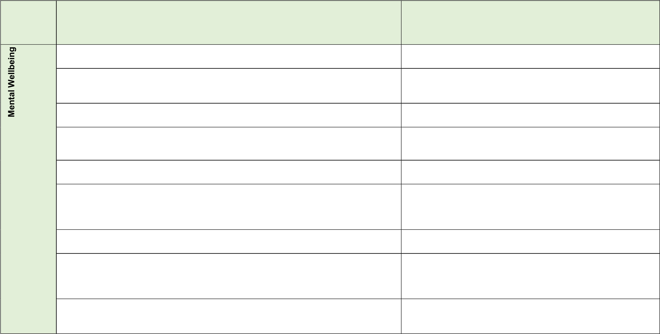where and how to seek support (including recognising the triggers for seeking Self-Care, Support and Safety: SSS3 support), including whom in school they should speak to if they are worried about their own or someone else’s mental wellbeing or ability to control their emotions (including issues arising online).
* it is common for people to experience mental ill health. For many people who do, the problems can be resolved if the right support is made available, especially if accessed early enough.

Relationships: Managing Feelings: MF1

|  |  |  |  |
| --- | --- | --- | --- |
|  | • | that for most people the internet is an integral part of life and has many benefits. | Self-Care, Support and Safety: SSS4 |
| • | about the benefits of rationing time spent online, the risks of excessive time spent on electronic devices and the impact of positive and negative content online on their own and others’ mental and physical wellbeing. | Healthy Lifestyles: HL2  Self-Care, Support and Safety: SSS3, SSS4 |

* how to consider the effect of their online actions on others and know how to recognise and display respectful behaviour online and the importance of keeping personal information private.
* why social media, some computer games and online gaming, for example, are age restricted.
* that the internet can also be a negative place where online abuse, trolling, bullying and harassment can take place, which can have a negative impact on mental health.
* how to be a discerning consumer of information online including understanding that information, including that from search engines, is ranked, selected and targeted.

Self-Care, Support and Safety: SSS3, SSS4

Self-Care, Support and Safety: SSS4

Self-Awareness: SA2

Self-Care, Support and Safety: SSS4

Self-Care, Support and Safety: SSS2 (Secondary framework)

* where and how to report concerns and get support with issues online. Self-Care, Support and Safety: SSS4
* the characteristics and mental and physical benefits of an active lifestyle. Healthy Lifestyles: HL2
* the importance of building regular exercise into daily and weekly routines and Healthy Lifestyles: HL3 how to achieve this; for example walking or cycling to school, a daily active mile or other forms of regular, vigorous exercise.
* the risks associated with an inactive lifestyle (including obesity). Healthy Lifestyles: HL2

* how and when to seek support including which adults to speak to in school if Healthy Lifestyles: HL3 they are worried about their health.
* what constitutes a healthy diet (including understanding calories and other Healthy Lifestyles: HL1 nutritional content).
* the principles of planning and preparing a range of healthy meals. Healthy Lifestyles: HL1
* 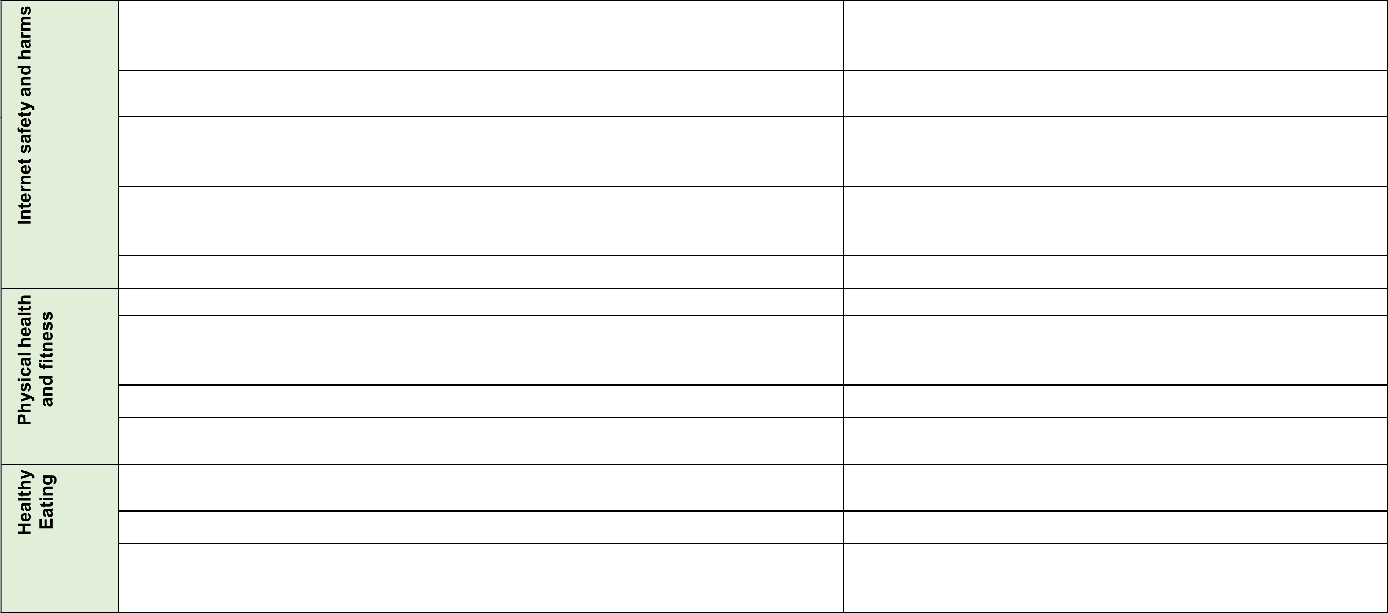the characteristics of a poor diet and risks associated with unhealthy eating Healthy Lifestyles: HL1 (including, for example, obesity and tooth decay) and other behaviours (e.g. the impact of alcohol on diet or health).

|  |  |  |  |
| --- | --- | --- | --- |
|  | • | the facts about legal and illegal harmful substances and associated risks, including smoking, alcohol use and drug-taking. | Healthy Lifestyles: HL3 |

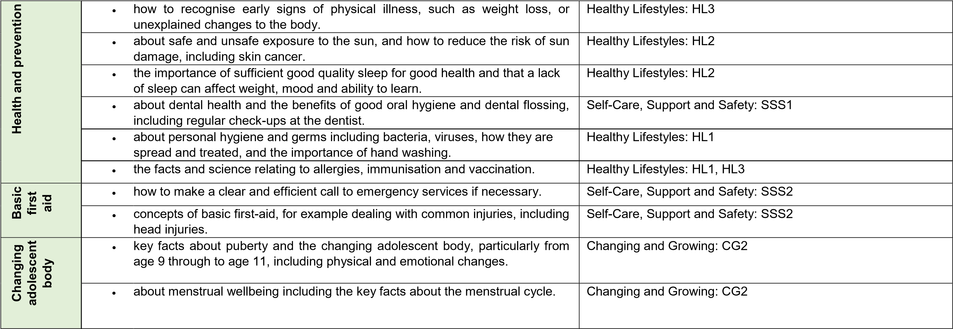

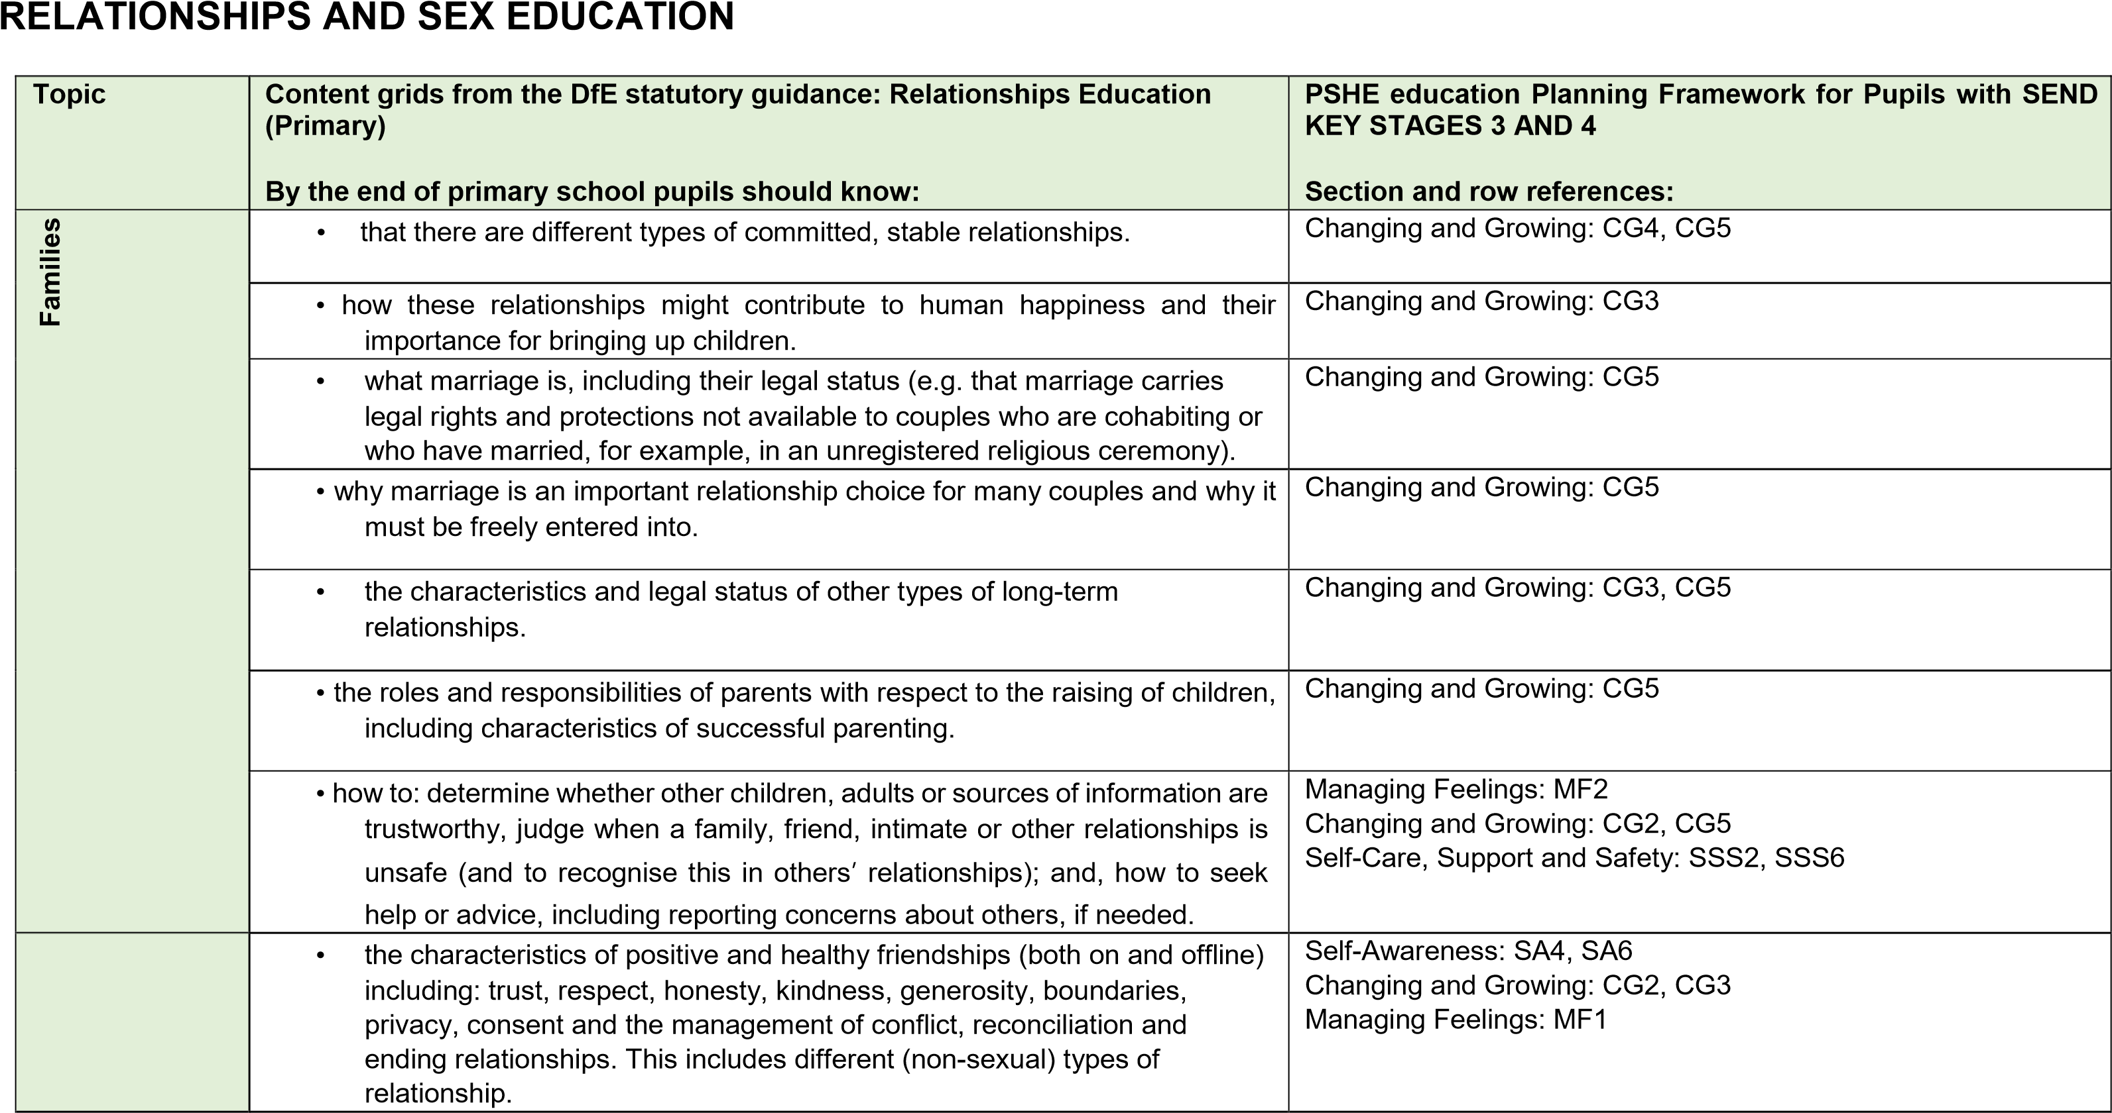

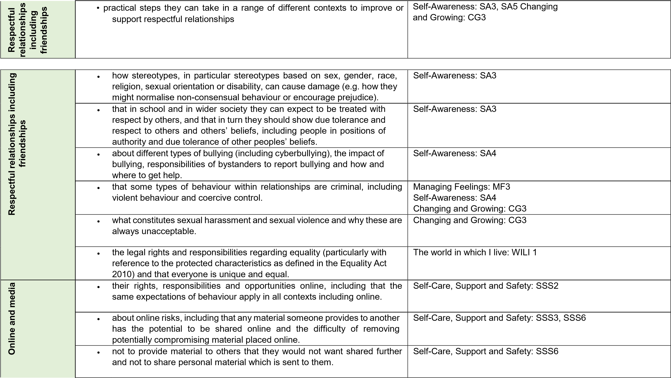

* that specifically sexually explicit material (e.g. pornography) often presents a distorted picture of sexual behaviours, can damage the way people see themselves in relation to others and negatively affect how they behave towards sexual partners.
* that sharing and viewing indecent images of children (including those created by children) is a criminal offence which carries severe penalties including jail.

|  |  |  |  |
| --- | --- | --- | --- |
|  | • | what to do and where to get support to report material or manage issues online. | Self-Care, Support and Safety: SSS2, SSS4, SSS6 |
|  | • | the impact of viewing harmful content. | Self-Care, Support and Safety: SSS2 Changing and Growing: CG4 |

Changing and Growing: CG4

Self-Care, Support and Safety: SSS6

Self-Care, Support and Safety: SSS6

* how information and data is generated, collected, shared and used online Self-Care, Support and Safety: SSS2

(partly).

* 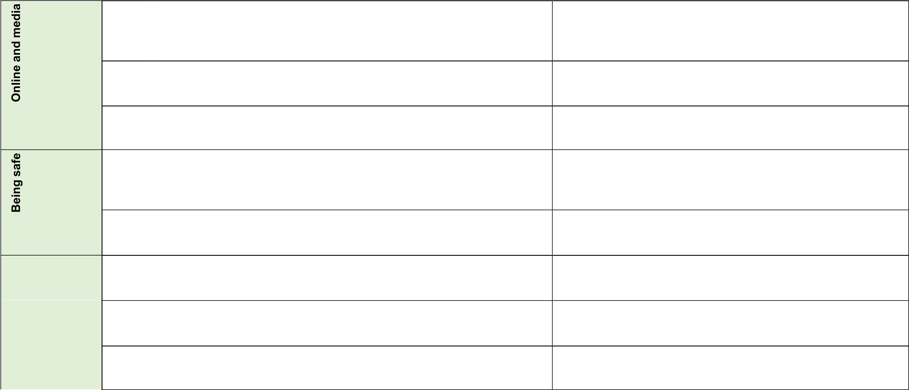the concepts of, and laws relating to, sexual consent, sexual exploitation, Self-Care, Support and Safety: SSS2 Changing abuse, grooming, coercion, harassment, rape, domestic abuse, forced and Growing: CG4 marriage, honour-based violence and FGM, and how these can affect current and future relationships.

* how people can actively communicate and recognise consent from others, Changing and Growing: CG4 including sexual consent, and how and when consent can be withdrawn (in all contexts including online).
* how to recognise the characteristics and positive aspects of healthy one- Changing and Growing: CG3, CG4 to-one intimate relationships, which include mutual respect, consent, loyalty, trust, shared interests and outlook, sex and friendship.
* that all aspects of health can be affected by choices they make in sex and Healthy Lifestyles: HL1 relationships, positively or negatively (e.g. physical, emotional, mental, sexual and reproductive health and wellbeing).
* the facts about reproductive health, including fertility and the potential impact of lifestyle on fertility for men and women.

Changing and Growing: CG4

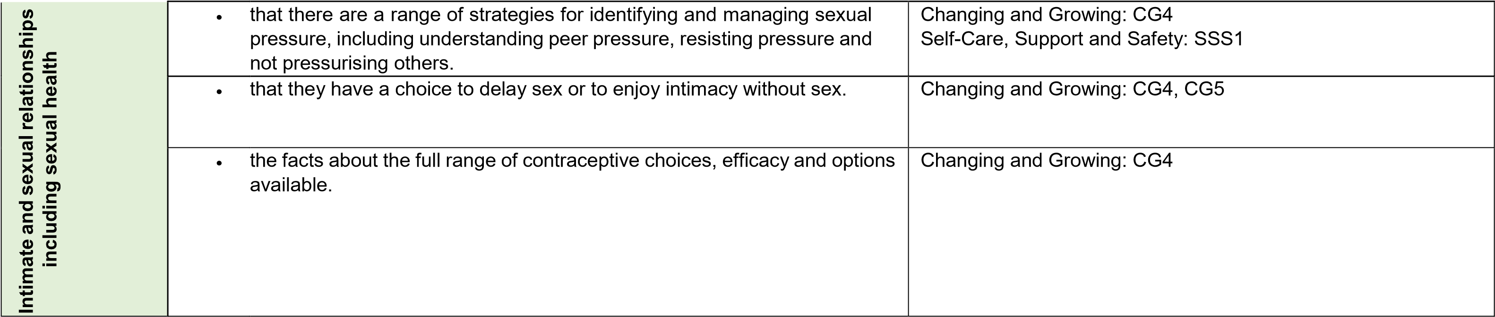

|  |  |  |  |
| --- | --- | --- | --- |
|  | • | that there are choices in relation to pregnancy (with medically and legally accurate, impartial information on all options, including keeping the baby, adoption, abortion and where to get further help). | Changing and Growing: CG5 |
| • | how the different sexually transmitted infections (STIs), including HIV/AIDs, are transmitted, how risk can be reduced through safer sex (including through condom use) and the importance of and facts about testing. | Changing and Growing: CG4 |
| • | about the prevalence of some STIs, the impact they can have on those who contract them and key facts about treatment. | Changing and Growing: CG4 |
| • | how the use of alcohol and drugs can lead to risky sexual behaviour. | Changing and Growing: CG4 |
| • | how to get further advice, including how and where to access confidential sexual and reproductive health advice and treatment. | Changing and Growing: CG4 |